**SBS Coordinate Detector, CDET: Manual for JLab Hall A Shifter Workers and Experts**

A condensed set of instructions for operation and maintenance of the Super BigBite Coordinate Detector, CDET. For questions, please contact an expert: Ralph Marinaro (7578488893) [ralph.marinaro@cnu.edu](mailto:ralph.marinaro@cnu.edu), Peter Monaghan [peter.monaghan@cnu.edu](mailto:peter.monaghan@cnu.edu), or Ben Spaude [btspaude@wm.edu](mailto:btspaude@wm.edu).

Created by Ralph Marinaro and Ben Spaude.

Winter of 2024 – first version.

Updates will be made in accordance with changes made to the detector and data acquisition system as the SBS experiment run groups progress.

**USE THIS CHEAT SHEET FIRST!!!!**

**CDET HV INSTRUCTIONS:**

* **ssh into aslow@adaqsc** 
  + **password available on request**
* **type go_hv, and EPICs gui will open**
* **navigate to CDET Left 1, Right 1, Left 2, and Right 2 tabs,**
* **use “on/off” buttons to turn on or off the HV channels only**
* **only use “on/off” buttons for HV channels** 
  + **do not touch the “Vset” or “Imon” or any other column other than the buttons in the “on/off” column**

**Contents**

**A. Summary Table**……………………………………………….. 3

**B. List of Shift Worker “How To”:**

**1.** Check the High Voltage Values……………………….. 4

**2.** Turn On the High Voltage………………………………. 6

a. Remotely

b. Via Controlled Access

**3.** Turn Off the High Voltage…………………………….. 10

a. Remotely

b. Via Controlled Access

**4.** Turn On the Low Voltage………………………..……. 14

a. Via Controlled Access

**5.** Turn Off the Low Voltage……………………………… 17

a. Via Controlled Access

**6.** Power Cycle LeCroy Crate…………………………….. 20

a. Remotely

b. Via Controlled Access

**C. List of CDET Expert “How To”:**

**1.** Change the High Voltage Values………………………

**2.** Troubleshoot Missing/Noisy Channels…………….

a. At the Detector

b. At the Patch Panels

c. At the TDC DAQ Crate

**3.** Turn On/Off the External Triggers………………….

a. Remotely

b. Via Controlled Access

**4.**  Reference Mapping

a. TDC Channels

b. HV Channels

c. LV Power Supplies

**5.** Reference Tables

a. PMT HV Values

b. Timing Cuts

c. Calibration Values

**6.** !!! ADD MORE EXPERT INSTRUCTIONS AS NEEDED !!!

**A.1 How to Troubleshoot the CDET:**

If one or a few channels appear to go missing, or become noisy, and the proposed solution requires a controlled access, then simply make a log entry on halog, and we will wait until the next planned access from the RC. If a whole NINO card worth of channels go missing, or are noisy, or the whole side of one side of the detector, or the whole detector itself, then first check the HV, LV, DAQ, and if necessary, contact an expert, and leave it up to their discretion for how to proceed.

|  |  |  |
| --- | --- | --- |
| Problem | Cause | Solution |
| Channels w/  No Data | Low Voltage OFF  High Voltage OFF  DAQ Errors | Turn On the Low Voltage** (**B4**)  Turn On the High Voltage* (**B2**)  Contact Expert  (by phone) |
| Dead/Noisy Channel(s) | 1 Channel  (Bad Connection)  14 Channels  (Loose Cable)  Half module,  or more (bigger  problem) | Contact Expert  (by email)  Contact Expert  (by email)  Contact Expert  (by phone) |
| High/Low Rate | High Voltages set too High/Low  NINO thresholds set too High/Low | Check HV Values (**B1**)  Contact Expert  (by email) |

** Requires controlled access, no remote control through EPICs

* Check on EPICs GUI first, then consider controlled access

**To Troubleshoot EPICs:**

**EPICS Instructions:**

ssh aslow@adaqsc

ps -aux | grep java

kill -9 #####

Where ##### is all the old or current java sessions. Restart the EPICs gui.

If there is still a problem, try to access HV control directly to the HV crate rpi8 by the following:

~need instrctions here, Ben unsure what they are

**Non-EPICS Instructions:**

~PUT HERE INSTRUCTIONS AND PHOTOS~ for using ./hvs LEFT HV control GUI

**B.1 How to Check the High Voltage Values:**

1. Using EPICs to check the high voltage values:

* From any Hall A computer in the command line type:
  + !!! type here instructions for getting to shared HV control vnc and starting EPICs gui if not already open !!!
  + ssh aslow@adaqsc
  + go_hv &
* The EPICS GUI will open, give it a few seconds. There will be drop down menus for all detectors, find and open the list of channels tabs for CDET Left Layer 1, Right Layer 1, Left Layer 2, and Right Layer 2.
* If all channels are on, then the PMTs are ready for taking data. The HV channels in all four tabs should look as follows:

~REPLACE PHOTOS HERE W/ CDET HV TABS~

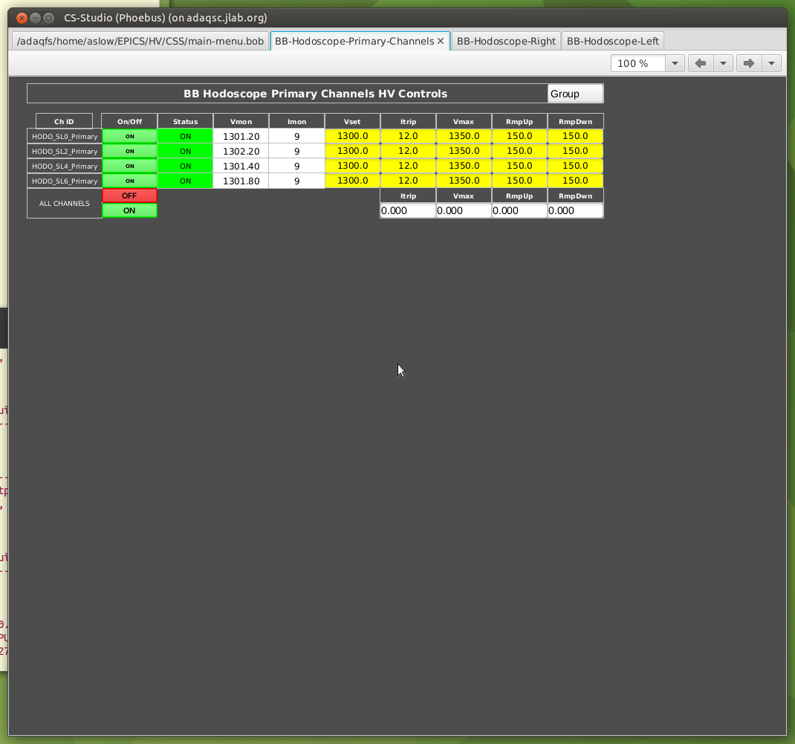

ON/OFF CONTROL BUTTONS

* If there is a disconnect in communication between EPICS and CDET HV channels this will appear as a purple border in the GUI around the problem channels
* If this happens, try the following:
* Sometimes killing the IOC on aslow@adaqsc will fix the CDet EPICS.

Look for

../../bin/linux-x86_64/ioccaen ./st.cmd

and kill it. It will restart.

**B.2 How to Turn On the High Voltage:**

**\*remote control is always the preferred first action**

**a.** Remotely Turning On High Voltage Main Frame:

* To use EPICs, as in section B.1, on any Hall A computer from the command line type:
  + !!! type here instructions for getting to shared HV control vnc and starting EPICs gui if not already open !!!
  + ssh aslow@adaqsc
  + go_hv &
* Use the EPICS gui to turn the high voltage on remotely, either press the ON bottom at the very bottom to turn on all channels in that tab or press the ON/OFF button on individual channels to turn on channels individually.

**b.** Manually Turning On the LeCroy HV Crate:

**\*requires controlled access**

* Only power cycle HV manually as a last resort and with agreed controlled access permission from the RC.
* Locate the CDet HV Crate on top of the left arm in Hall A
* 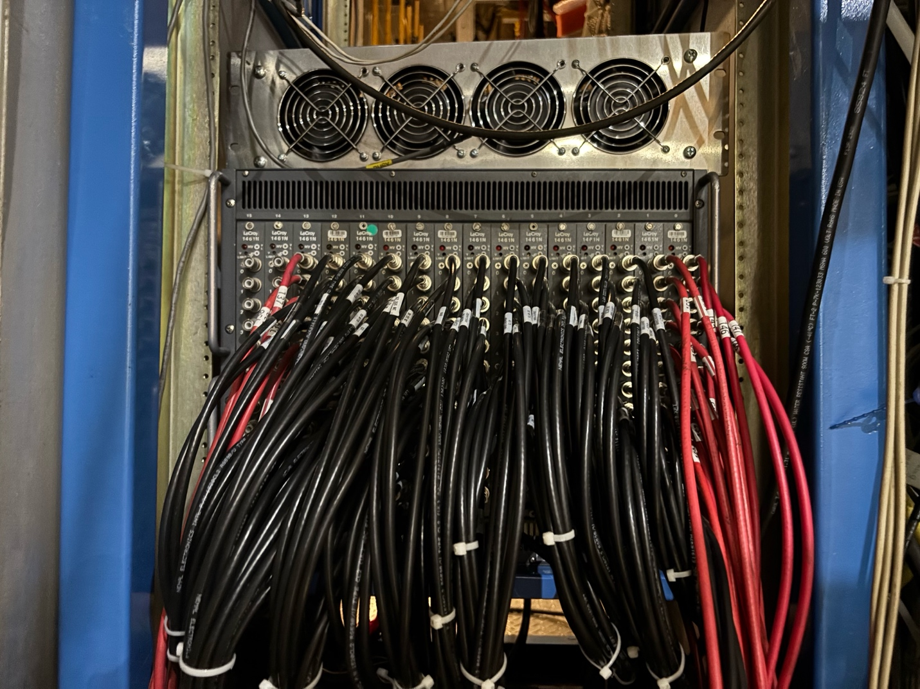Need picture up top of arm, but with HV a bit in the distance, will also be useful for tdc stuff

**CDet HV Crate**

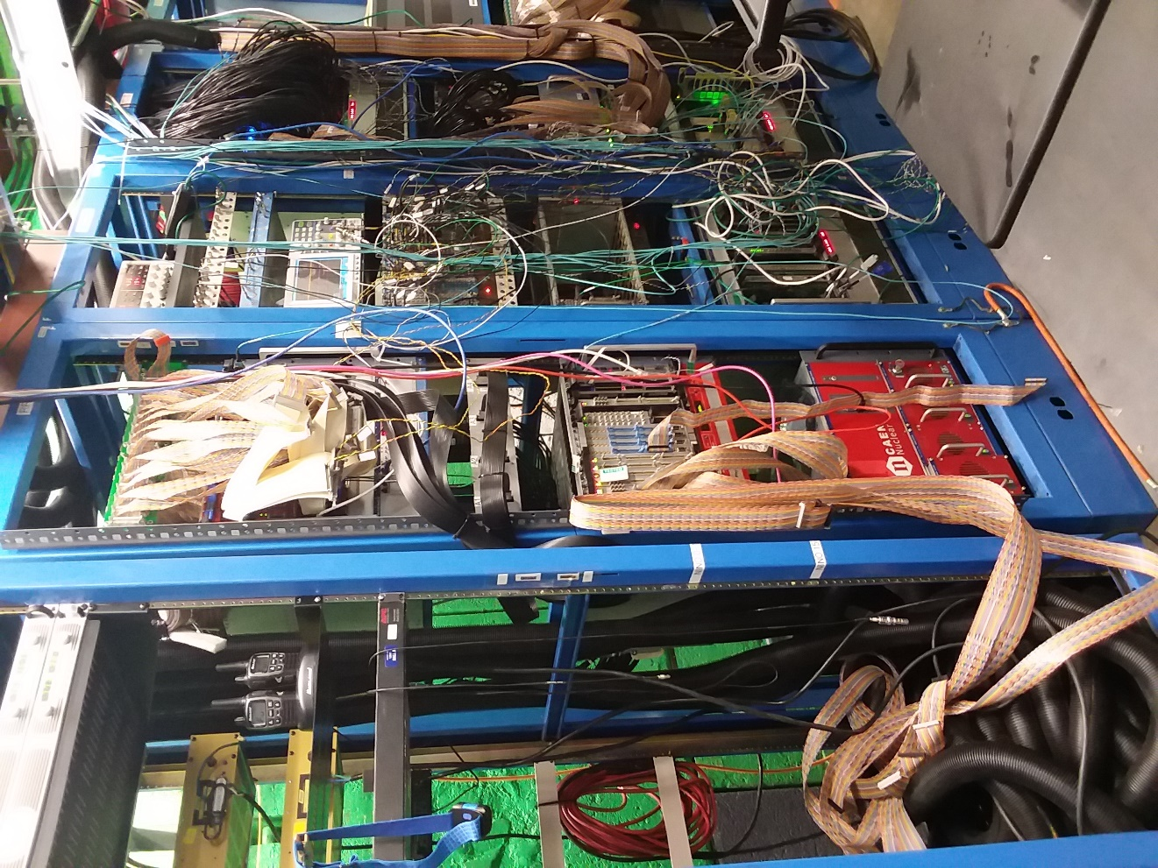

**HIGH VOLTAGE MAIN FRAME**

REPLACE WITH CD HV MAIN FRAME, SHOWING SWITCH, need picture

* Turn the power key from “OFF” position to the right so the power key is in the “LOC” position

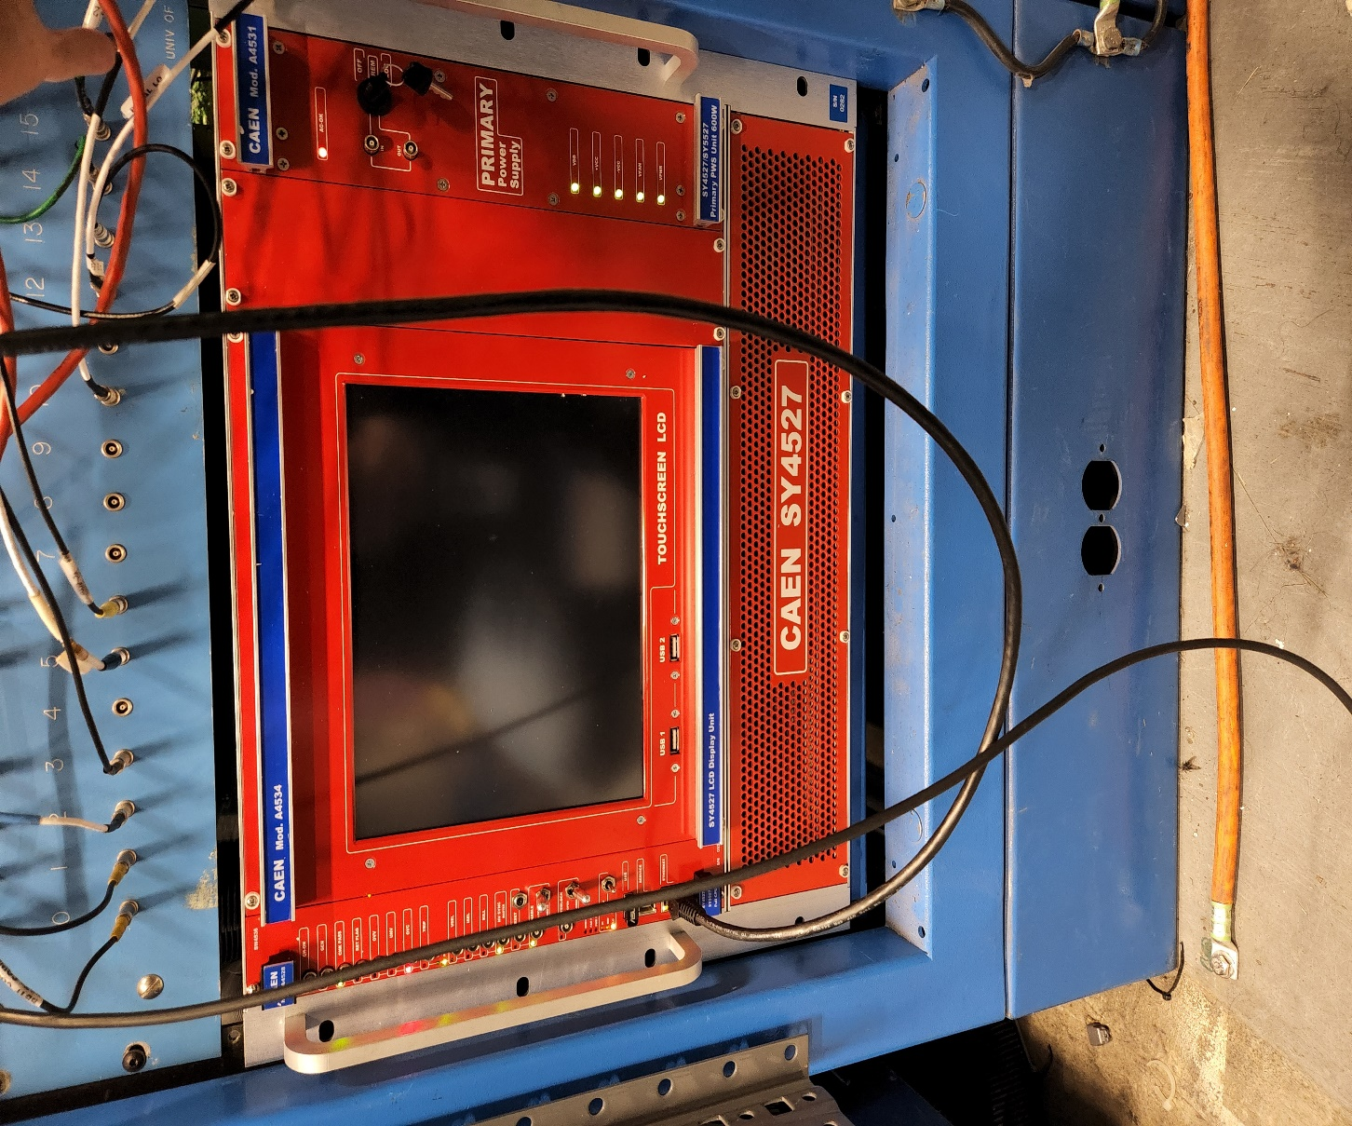

**POWER KEY**

* If the high voltage main frame does not turn on, check the power switch on the back of the high voltage main frame. If that does not work, then please contact an expert for help.

**B.3 How to Turn Off the High Voltage:**

**\*remote control is always the preferred first action**

**a.** Remotely Turning Off High Voltage Main Frame:

* To use EPICs, as in sections B.1 and B.2, on any Hall A computer from the command line type:
  + !!! type here instructions for getting to shared HV control vnc and starting EPICs gui if not already open !!!
  + ssh aslow@adaqsc
  + go_hv &
* Use the EPICS gui to turn the high voltage off remotely, either press the OFF bottom at the very bottom to turn off all channels in that tab or press the ON/OFF button on individual channels to turn off channels individually.

**b.** Manually Turning Off the High Voltage Main Frame:

**\*requires controlled access**

* Only power cycle HV manually as a last resort and with agreed controlled access permission from the RC.
* Locate the SBS detector electronics bunker in Hall A

~REPLACE PHOTOS AND INSTRUCTIONS BELOW W/ CDET HV PHOTOS AND INSTRUCTIONS~

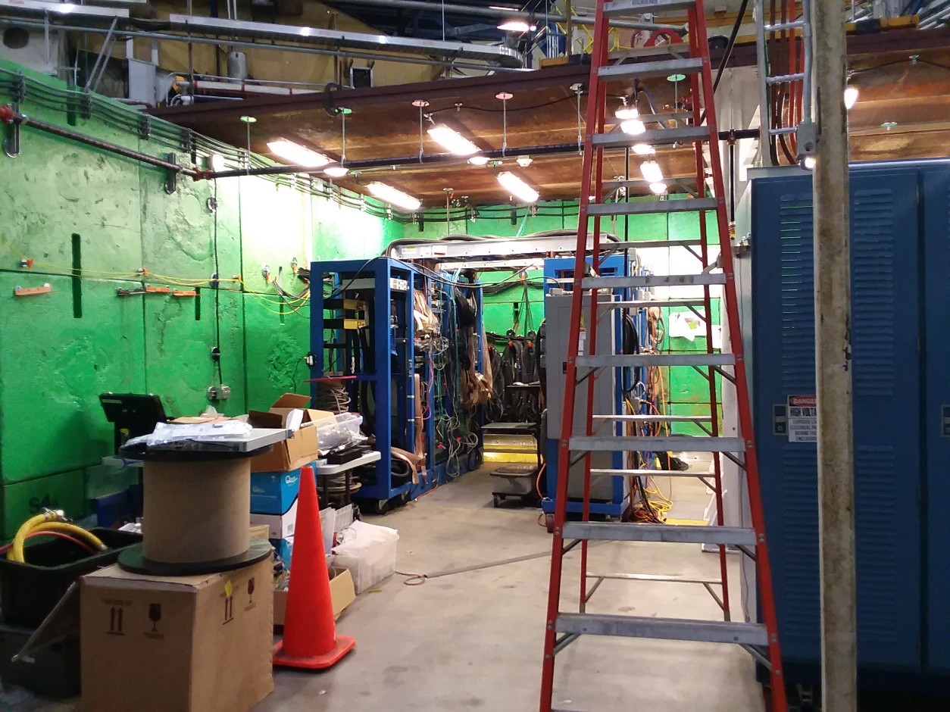

**TIMING HODOSCOPE ELECTRONICS RACK**

* Locate the electronics rack housing the high voltage main frame



**HIGH VOLTAGE MAIN FRAME**

* The power key should be in the “LOC” position, turn the power key to the left so the power key is in the “OFF” position.



**POWER KEY**

* If the high voltage main frame does not turn on, check the power switch on the back of the high voltage main frame. If that does not work, then please contact an expert for help.

**B.4 How to Turn On the Low Voltage:**

**\*requires controlled access**

**a.** Manually Turning On Low Voltage Power Supply:

~REPLACE PHOTOS AND INSTRUCTIONS BELOW W/ CDET HV PHOTOS AND INSTRUCTIONS~

* Locate the CDet electronics in the mini bunker in Hall A

~Need to add picture of mini-bunker

* Locate the electronics rack housing the low voltage power supply

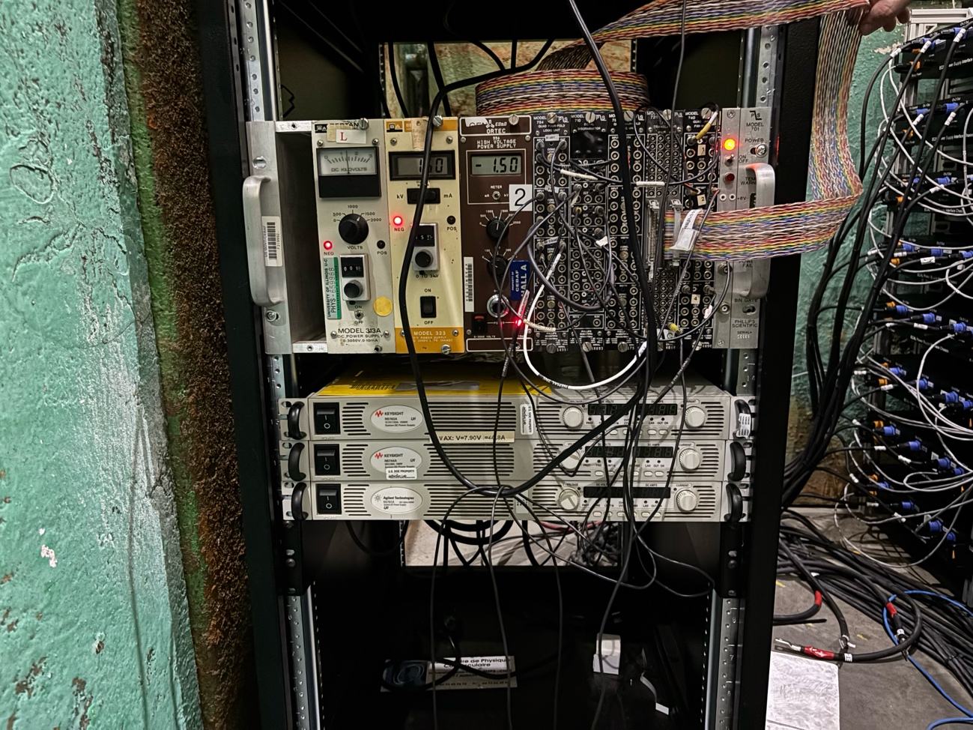

**LOW VOLTAGE POWER SUPPLY**

* The power switch should be in the off position, flip the power switch to the on position. Adjust the voltage or current controls until the supply reads ~**7.1** volts and ~**15.79** amps.
* These values are set such that the NINO cards receive the minimum **5** volts necessary, and their thresholds are set to **1.6** volts.

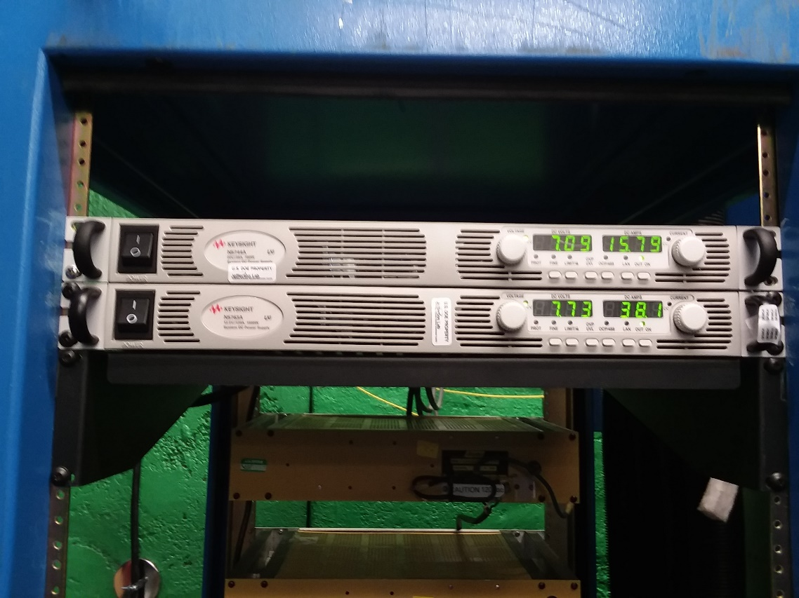

**POWER SWITCH** **SUPPLY CONTROLS**

* If the low voltage power supply does not turn on, or if one of the supply controls do not work properly, then please contact an expert for help. REPLACE WITH UPDATED PICTURE, W/ CORRECT VOLTAGE AND CURRENT

**B.5 How to Turn Off the Low Voltage:**

**\*requires controlled access**

**a.** Manually Turning Off Low Voltage Power Supply:

~REPLACE PHOTOS AND INSTRUCTIONS BELOW W/ CDET HV PHOTOS AND INSTRUCTIONS~

* Locate the CDet electronics in the mini bunker in Hall A



**TIMING HODOSCOPE ELECTRONICS RACK**

* Locate the electronics rack housing the low voltage power supply



**LOW VOLTAGE POWER SUPPLY**

* The power switch should be in the on position. Adjust the voltage or current controls until the supply reads ~**0.0** volts and ~**0.0** amps, then flip the power switch to the off position.



**POWER SWITCH** **SUPPLY CONTROLS**

* If the low voltage power supply does not turn off, or if one of the supply controls do not work properly, then please contact an expert for help.

**B.6 How to Power Cycle TDC DAQ Crate:**

**\*requires controlled access**

**a.** Manually Power Cycling the TDC DAQ Crate:

~REPLACE PHOTOS AND INSTRUCTIONS BELOW W/ CDET TDC PHOTOS AND INSTRUCTIONS~ NOTE, BEN WILL UPDATE THESE PHOTOS WHEN TDC PLUGGED BACK IN

* Head up the stairs to the DAQ racks on top of the left arm and locate the TDC DAQ.



**CDET TDC CRATE**

* Locate the electronics rack housing the VME crate.

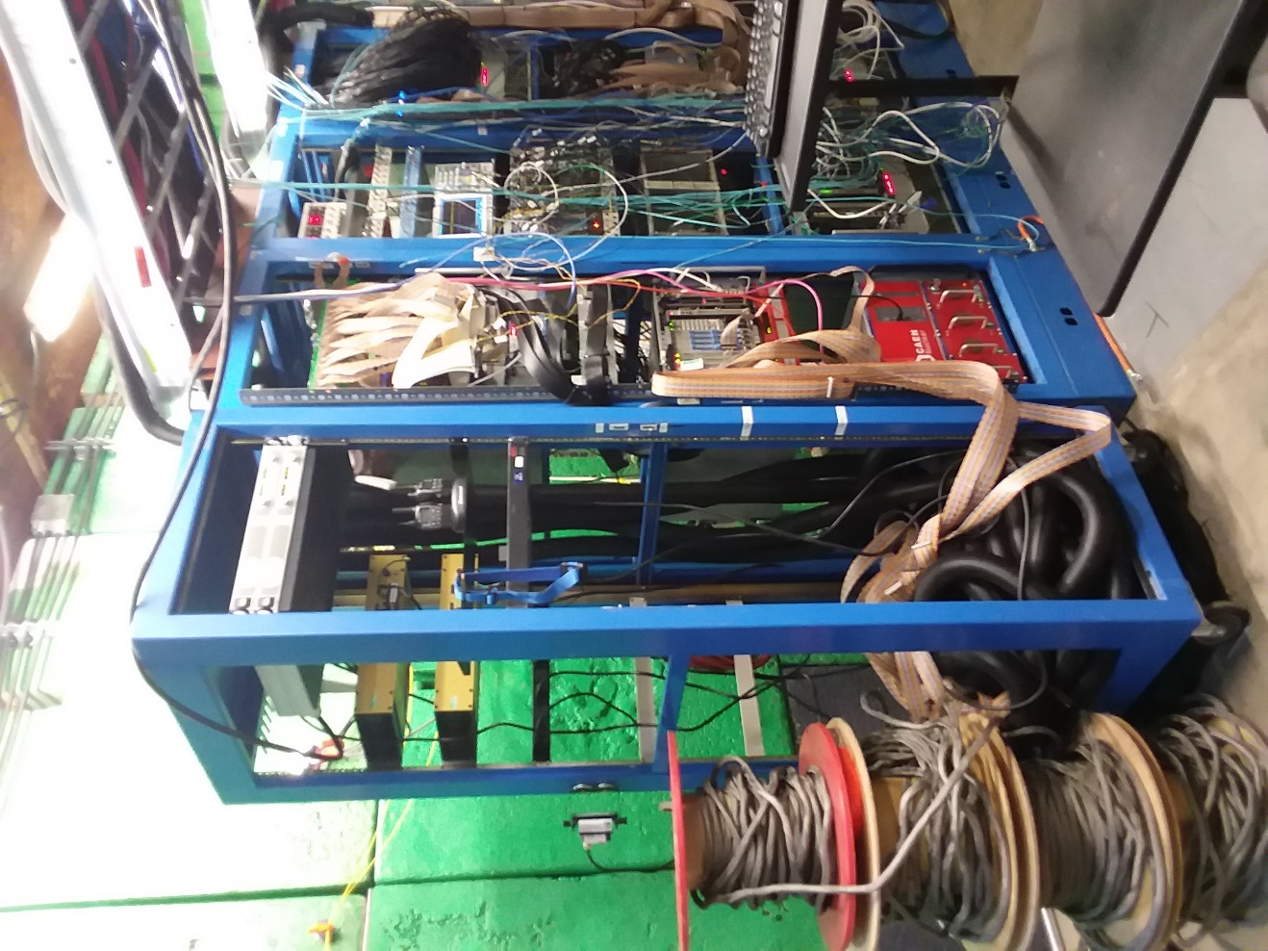

**VME CRATE**

* The power switch should be in the on position. Flip the power switch to the off position and then the on position to power cycle the VME crate.

~~~~Replace picture after plugging in the tdc cables, make sure switch is visible

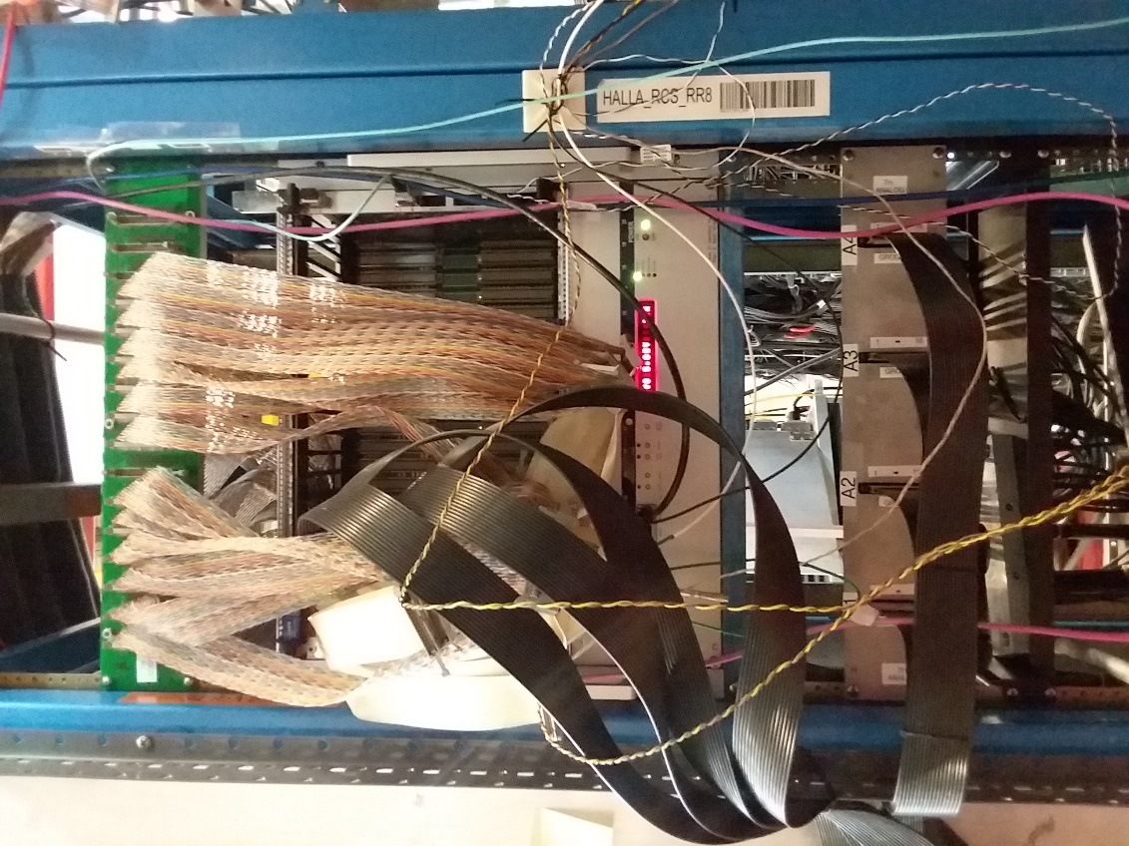

**POWER SWITCH**

* If the VME crate does not power cycle correctly, then please contact an expert for help.

**C.1 How to Change the High Voltage Values:**

* **In EPICs GUI:**
* **Alternate GUI:**

**C.2 How to Troubleshoot Missing/Noisy Channels:**

**a.** At the Detector

**b.** At the Patch Panels

**c.** At the TDC DAQ Crate

**C.3 Turn On/Off the External Triggers:**

**a.** Remotely

**b.** Via Controlled Access

**C.4 Reference Mapping:**

**a.** TDC Channels

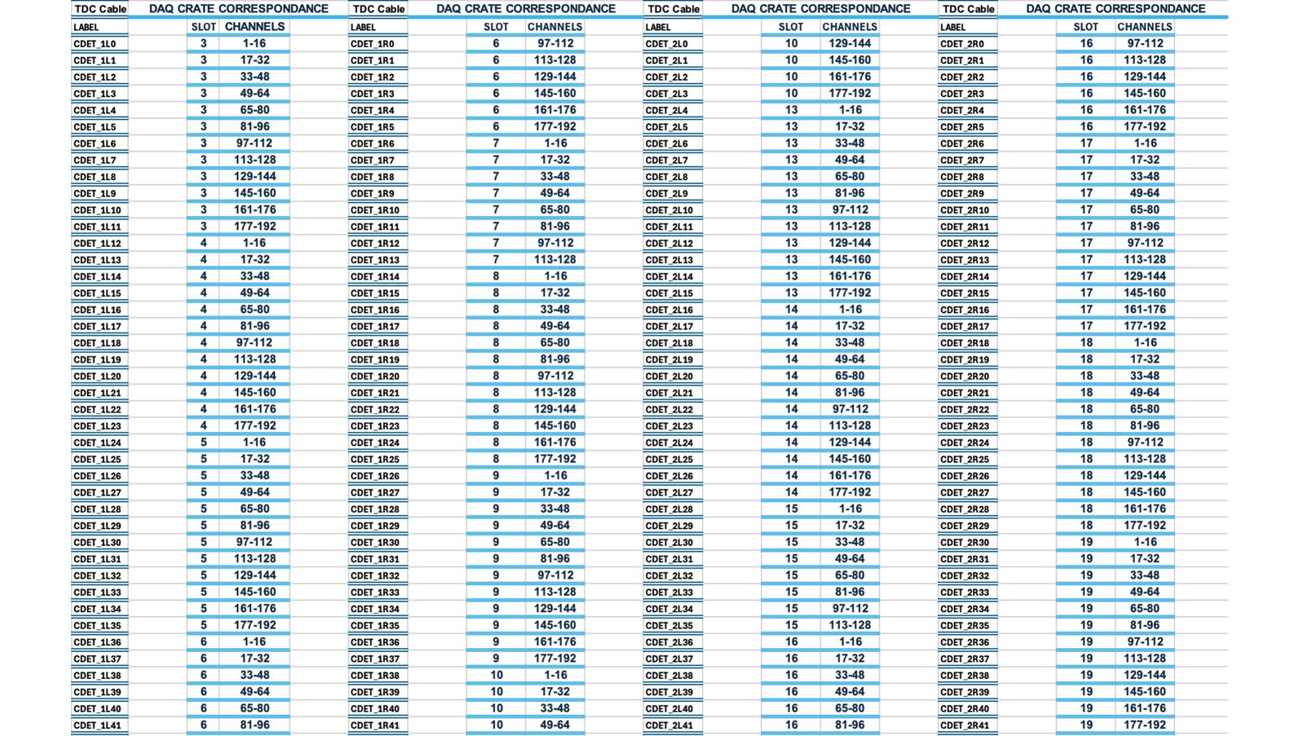

**Figure xx: This figure shows the correspondence between CDet cables and the DAQ Crate**

**b.** HV Channels

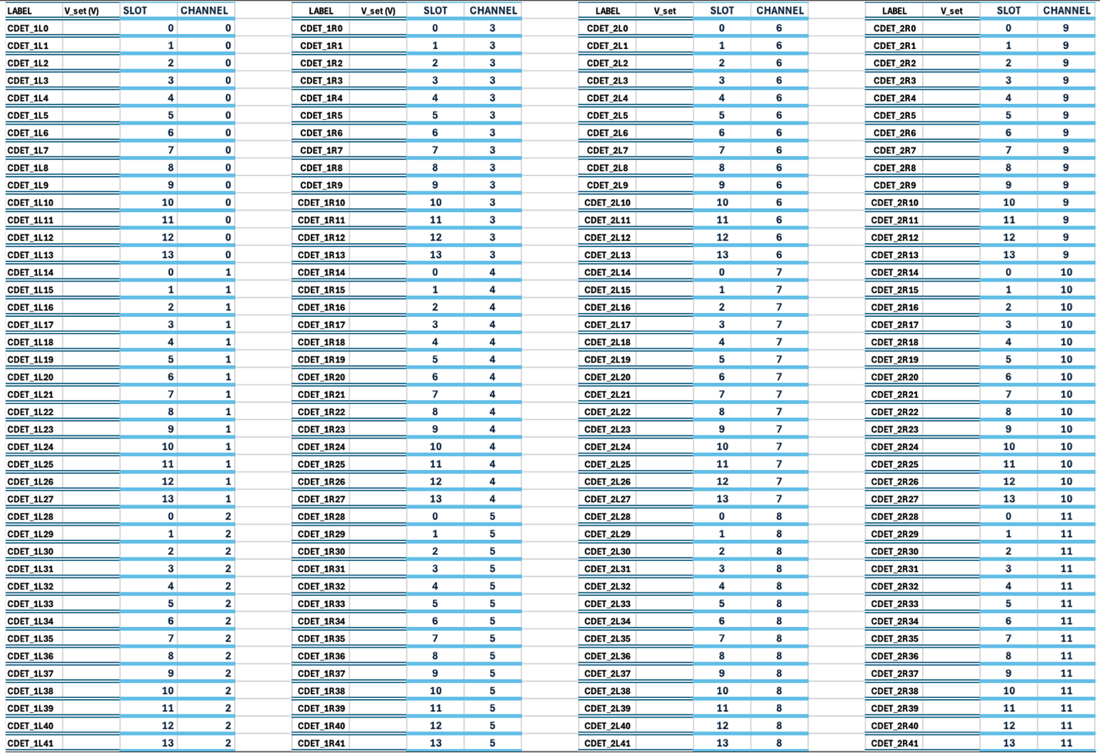

**Figure xxx:** This figure shows the correspondence between CDet HV cables and their location on the HV Crate, along with the optimal voltages for each maPMT.

**c.** LV Power Supplies

need pictures of LV Power supplies once plugged in

**C.5 Reference Tables:**

**a.** PMT HV Values --- Ralph add?

**b.** Timing Cuts—need to do analysis still

**c.** Calibration Values—need to do analysis still